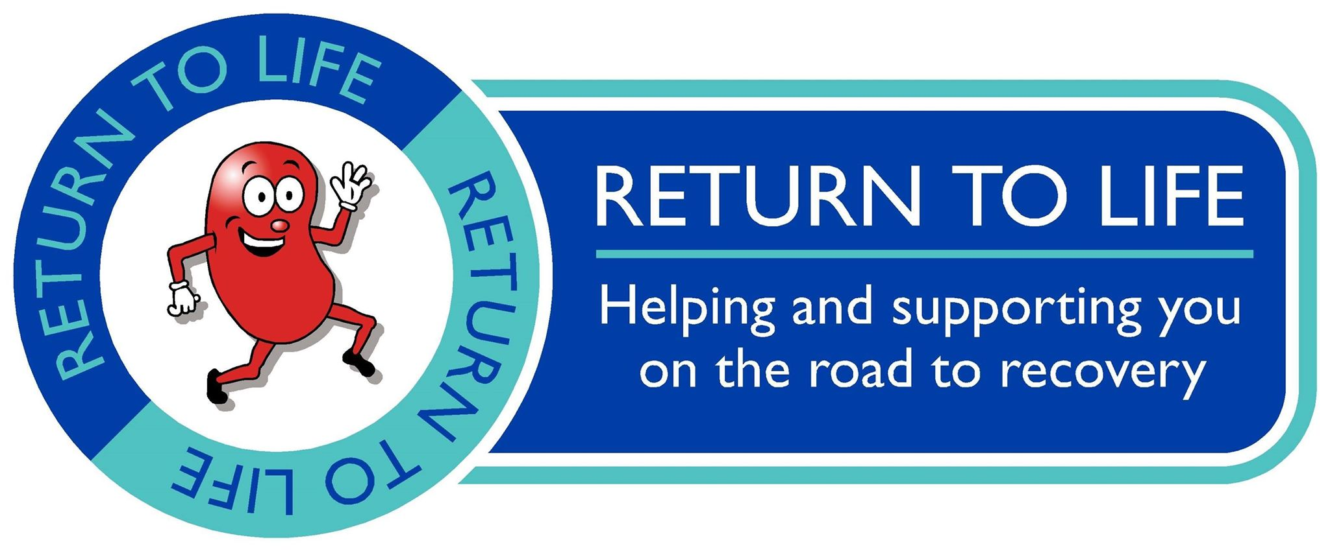

Welcome to the GTR/Return to Life charity 10 mile TT on the A78 Eglinton Park course which was used in last years British 10 mile TT championship.
It’s a pretty straightforward course, cycle out 5 miles to the papermill/dundonald camp roundabout, turn round and ride 5 miles back, you can’t go wrong. That being said it’s the riders responsibility to familiarise yourself with the course and LOOK where you are going. Where the road goes from three lanes to two you MUST look over your shoulder to check it is safe, same for the turn, IT IS NOT the marshals responsibility to tell you it’s safe or not. On the return leg there are a few potholes which have been filled in, But are still a little rough. Look out for them and stay safe.
It’s the rider's responsibility to make sure the bike is maintained and safe to ride. There have been crashes on this course before due to bikes not being safe, and we will stop you from riding if the bike isn't safe.
Finally, as this is a charity event with the aim of raising funds for Return to Life, I’m running on a minimum budget (apart from prizes), old school, back of the car job. Public parking is plentiful within the park, Although with Parkrun being run early doors as well, The car parks may be quite busy. Shouldn’t be an issue for the guys on later. The race HQ will be the same place as last year's GTR 10, Under the wooden shelter just over from the car park.
Enjoy!!

Course description
10 Mile TT

AY4 - Start at lamp no.R5 opposite entrance to Eglinton Country Park. Follow A78 south, under two interchanges and turn at Dundonald Camp Roundabout. Return to finish on slip road at Eglinton Interchange.

http://www.gmap-pedometer.com/?r=5913085

